Assignment 2

Student Name -Vishal Bose (vishalbose049@gmail.com)

Q/1. Create a file like nano file1.txt

o Edit some data and then save the file

Steps performed :  
1.Open Terminal  
2.Type the command nano file1.txt

3.It will open the file in editor mode

We can type the contents

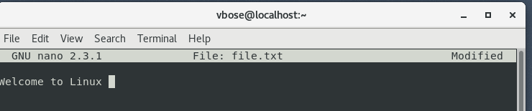

4.Press Ctrl + O to save the file

5.Press ctrl + X to exit and it will ask to save the content select yes and hit enter

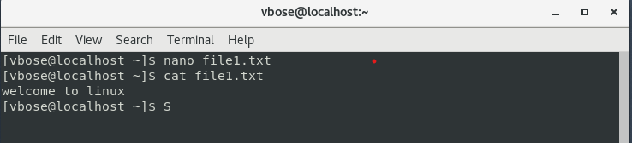

Q/2. Now we will copy data from file1 to new file2

o cp file1.txt file2.txt

o Then see the output of file2.txt, cat file2.txt

o Give screenshot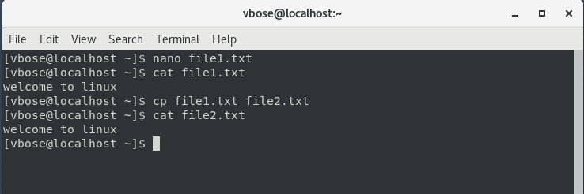

Q/3. Now we will move the file2.txt to new folder /home

o mv file2.txt /home

o Then go to home directory and check ls, file exits or not?

o Given screenshot

if we try to do the above operation as normal user it will show permission denied as normal user the does not have execute access in the /home directory hence we need to provide execute access to other user and then we can execute mv command

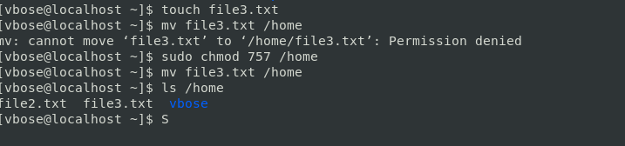

Yes the file exists in home directory

Q/4. Then we create a new file3.txt and file4.txt in home directory and add

content in it.

o Now do echo “Hello I am newline” > file3.txt and provide the

output of file3.txt

o Now do echo “Hello I am newline” >> file4.txt and provide the

output of file4.txt

o Tell the different between both step you follow and the reason

behind it

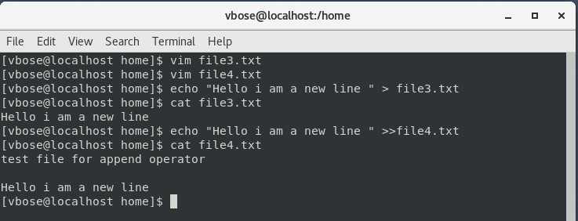

>,>> are operators user for redirecting the output of a command to files

> = it overwrites the content of the file with new ones

>>- it appends the present content of the file with new contents

5. For remove a file or directory you can use the below two commands

o To delete a file – rm <any_filename>

